
Company
Logotype

Cone Beam Computed Tomography- Report



Porur Dental X-rays & CBCT

Patient Name : Mrs. Chandra | Date of Report : 01.09.2024
Age/ Gender : 77 years/ Female | Region of Interest : CBCT Sectional Mandible
Referring doctor: Dr. Lakshmi | Indication : Implant assessment
Clinical Notes: Nil
PATIENT INFORMATION

CBCT- Mandible provided
CBCT – IMAGE DETAILS

RADIOGRAPHIC INTERPRETATION

- Completely missing crown and root portion in relation to 47.
- In relation to 46, presence of bone loss extending 4.55 mm below the cementoenamel junction of 46 in distal aspect is evident.
- In relation to 45, presence of restorative material in relation to the disto- coronal portion of 48 is evident.
- The alveolar bone in relation to the mandible is present with normal trabecular pattern.

IMPLANT ASSESSMENT

 | 46 region | 47 region
Sub-Crestal (in mm) | 8.96 | 12.48
Mid- Crestal (in mm) | 9.1 | 11.27
Distance between alveolar ridge and the inferior alveolar nerve canal (in mm) | 10.86 | 4.23
Distance between alveolar ridge and the inferior border of mandible (in mm) | 20.91 | 15.29

RADIOGRAPHIC IMPRESSION

- Chronic periodontitis: 46
- Partially edentulous region: 47.
- Restored tooth: 48

Kindly correlate with clinical findings


IMAGES FOR REFERENCE

RECONSTRUCTED PANORAMIC VIEW
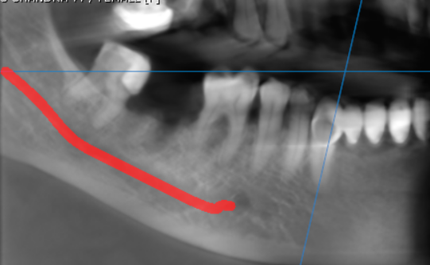

3-DIMENSIONAL VIEW

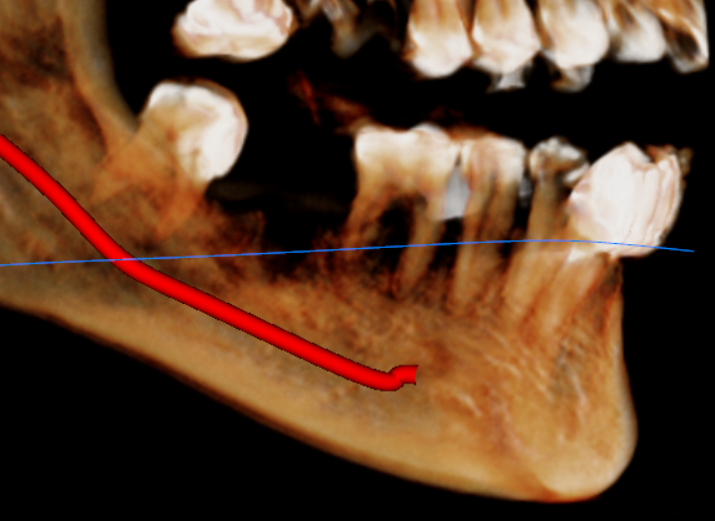

CROSS SECTIONAL VIEW

46 region | 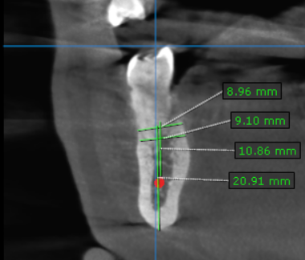
47 region | 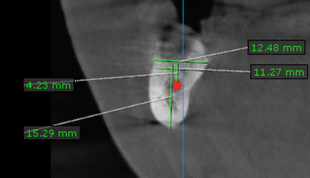

**** End of report ****

